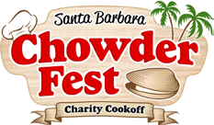

presents
The 7thAnnual Santa Barbara Chowder Fest SUNDAY October 16, 2016 ~ 1:00-4:00 PM at
The Fess Parker: A Doubletree by Hilton Resort

633 East Cabrillo Blvd., Santa Barbara, CA 93101

AUCTION DONATION FORM

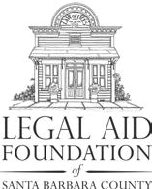
Business Name:

Contact Person and Title:
Phone Number: Address:

Email:

Please include an address so that we may send you an acknowledgement letter.

Silent Auction Item Value $

Item Description:

Please fill out and return form and item to: The Legal Aid Foundation, 301 E. Canon Perdido Street, Santa Barbara, CA 93101 (Fax:) 805.963.6756 | (Phone:) 805.963.6754 x 103 (Email:)managing.director@lafsbc.org

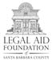
A 501 (c)(3) charity; all contributions are fully tax-deductible as provided by law. IRS No. 95-2112634.

